|  |  |  |
| --- | --- | --- |
|  | |  |
| WELCOME TO BPCL | |
| MAGAR PETROLEUM | |
| 142/6 HADAPSAR | |
| PUNE-411028 | |
| GST NO. 27AAKFM6124D1ZF | |
| Date: | 20-02-2023 |
| Time: | 09:05:23 |
| BayNo: | 5 |
| NozzleNo: | 1 |
| Product: | PATROL |
| PayMode: | Cash |
| Txn Id: | 3225627900 |
| Attendant: |  |
| TxSt: | 20-02-23 09:05:23 |
| TxEnd: | 20-02-23 09:05:41 |
| Rate/Ltr: | 105.83 |
| Volume (Ltr.): | 32 |
| Amount (Rs.) | 3386.56 |
| PresetType: | Local Amount |
| Preset Value: | 3386.56 |
| VechNo: | MH 12 JZ 5160 |
| MobileNo: |  |
| THANK YOU VISIT AGAIN | |

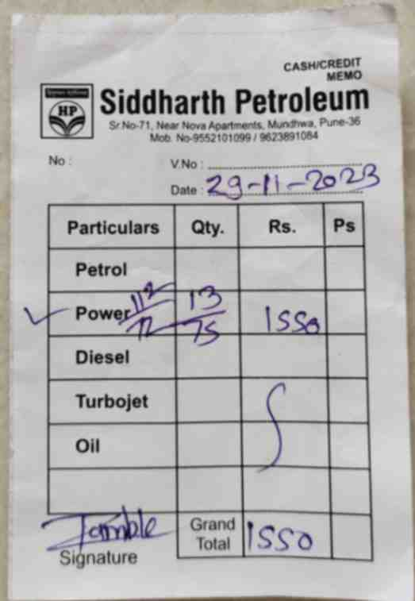

|  |  |  |  |
| --- | --- | --- | --- |
|  | | | |
| No. | | V.No: | |
|  |  | Date: | |
| **Particulars** | **Qty.** | **Rs.** | **Ps** |
|  |  |  |  |
|  |  |  |  |
|  |  |  |  |